CHAUDHARY HAMDAN

1905387

Networks Lab 10

Q1. Using Router in Cisco Packet Tracer.

Commands to configure a router:-

no

enable

config terminal

hostname Router-0

interface GigabitEthernet0/0

ip address 192.168.1.1 255.255.255.0

no shutdown

exit

interface GigabitEthernet0/1

ip address 192.168.2.1 255.255.255.0

no shutdown

exit

exit

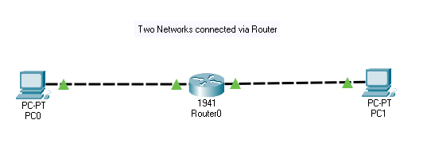

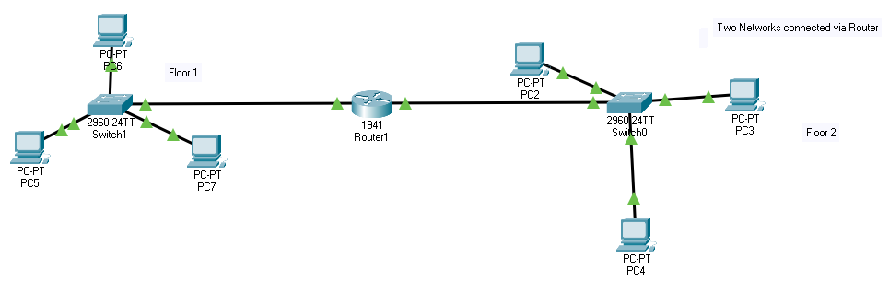

Q2. Configure a network in an office where we have 2 floors in the office building, the ground floor will have network of 5 PCs with class C IP addresses, and the 1st floor of the officewill have a network of 10 pc of class B IP address. Connect these 2 networks with router and then test the connectivity.

